FULL NAME: PETER JENNINGS

Personal details
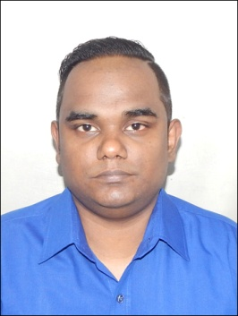
Date of Birth : 12th July 1989
Gender : Male
Nationality : Indian
Religion : Christian
Marital Status : Single
Address : 72/3 Surendra Nath Banerjee
Road, Waverly Mansions, Flat
No:15, Moulali, Kolkata-700014
Landmark : Calcutta Boys School
Mobile Number : +91 9007166164
Father Name : Brian Jennings
E-Mail : petermajennings@gmail.com

Professional Summary

Worked in the fields of Customer Service/Delight, Sales, Data Entry and mentoring other agents in both Smart Call Center (Inbound and Outbound) and Retail Oriented Organizations.

Worked in the fields or logistics and tracking and also as Technical Assistant.

Worked for Australian Shift.

Educational Qualification

Completed Indira Gandhi National Open University (IGNOU) in 2008 – Class X

Completed Indira Gandhi National Open University (IGNOU) in 2013 – Class XII

Employment

HelloConsulting
10/02/21 - 11/04/21

Lead Generation for Australian Proceess.

12/08/21 - 1/23/22
Choice Force and Teleminds
5 Months experience in Lead Generation for Australian Energy Proceess.

Smart Call Center Solutions (P) Ltd.
2008 - 2019
Outbound / Inbound agent
Customer Care Executive / Sr. Customer Care Executive
Tele-marketing for various clients of the firm
Verification Officer, Process Specialist and Team leader
Closing of Direct sales
Handling of Clients and Customer Complaints
Handling of the Team

Part of training Fresher’s

2008 - 2019: Worked in Smart Call Center Solutions (P) LTD.
2008 - 2010: Worked as an out bound agent for Loss Mitigation
2010 - 2011: Worked as inbound Sales representative for Loss Mitigation Loan, Modification Office
2011 - 2013: Worked as a back office representative submitting report and data entry for Loss Mitigation
2014 - 2015: Customer Service agent (SEO)
2016 - 2019: Customer Service Manager (SEO)

Total Work Experience: 12 Years.

Date: Signature: __________________
(Peter Jennings)

